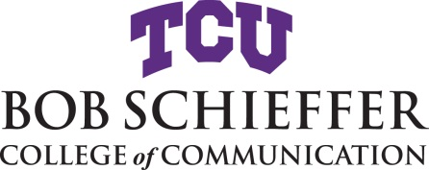

Information and Deadlines for Graduation:
Thesis Spring 2020

Thesis is a total of six (6) hours and consists of two courses taken in proper order.
Strategic Communication Thesis Courses: STCO 70980 – (first thesis course) and STCO 70990 – (second thesis course)
Communication Studies Thesis Courses: COMM 70980 – (first thesis course) and COMM 70990 – (second thesis course)
Committee chairs must have course and section numbers available for the semesters of enrollment.

Must be on File File Master’s Committee form. Student must file this form prior
Before Enrollment to enrollment in classes.
by Jan. 13, 2020

January 17, 2020 File an Intent to Graduate form.
Last day for enrollment or changing classes
A nonrefundable fee is charged to the student when an Intent to Graduate is filed.

April 29, 2020 Oral defense of your thesis should be completed by this date.
Last day of class Final Grade Report form is completed and signed by the committee and digitally emailed to j.oneil@tcu.edu.

The Title page is also digitally signed at this time for scanning into electronic copy.

An electronic copy of the thesis should be emailed to j.oneil@tcu.edu. It should be carefully proofread and in its final form according to the College of Communication Thesis Graduate Manual, except for any changes that might be suggested at the final oral.
May 6, 2020 All thesis paperwork completed and final electronic copies submitted to UMI.
Students can pay the fee on their student account via Web Check (https://stupay.tcu.edu/studentPayments/) or credit card.
For more information on how to submit thesis go here: https://lib.tcu.edu/submit-thesis-or-dissertation.asp#tab_explanation.

May 9, 2020 Baccalaureate & commencement

Should it be necessary to delay graduation, you must complete and submit a Cancel Intent to Graduate form.
Another Intent to Graduate form and associated fee will be required for your new graduation date.

