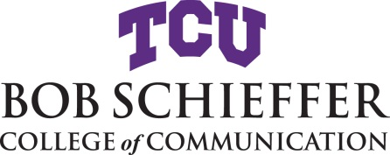

Information and Deadlines for Graduation
Communication Studies: Comprehensive Exams
Strategic Communication: Projects

Must be on File File Master’s Committee form. Project students must file this form prior
Before Enrollment to enrollment in classes.
by Jan. 13, 2020

MS in STCO: Enroll in STCO 60173 – Project in Strategic Communication

January 17, 2020 File an Intent to Graduate form.
Last day for enrollment or changing classes
A nonrefundable fee is charged to the student when an Intent to Graduate is filed.

April 29, 2020 Projects and Comprehensive orals must be completed no later than this date.
Last day of class Final Grade Report form is completed and signed by the committee
then returned to the Graduate office in MOUS 207.

May 6, 2020 Graduating students’ grades due by 5PM

May 9, 2020 Baccalaureate & commencement

Should it be necessary to delay graduation, you must complete and submit a Cancel Intent to Graduate form.
Another Intent to Graduate form and associated fee will be required for your new graduation date.

